# AWS EC2

## EBS

* Used to create storage volume and attach to EC2 instance.
* Placed in specific AZ to protect from failures.

### EBS volume types

* General Purpose SSD (GP2)
  + General purpose balances both price and performance.
* Provisioned IOPS SSD (IO1)
  + Used for application such as large relational or NoSQL DB.
* Throughput Optimized HDD (ST1)
  + For frequently accessing
  + Can’t be a boot Volume.
  + Magnetic storage.
  + Used for
    - Big Data
    - Log processing
    - Data warehousing
* Cold HDD (SC1)
  + Lowest cost storage for infrequently accessed records.
  + Can’t be a boot Volume.
* Magnetic (Standard)
  + Bootable
  + Lowest cost/GB
* Can’t Mount 1 EBS volume to multiple EC2 instances.

### Amazon Machine Image (AMI)

* Snapshots of virtual machine.

### LAB Points:

* One subnet = One AZ
* For SSH, we will use the public ip address.
* Types of Status Checks
* System Status Check: Monitor the AWS system where EC2 instance runs.
* Instance Status Check: Monitor the Software and N/W config. on our instance runs.
* We can’t encrypt the root device volume by default (But you can do it ).
* Termination Protection turned off by default.
* Default behavior is that once Ec2 instance is deleted, corresponding EBS volume will get delete.

### Security Group Points:

* Any rule that added/removed to security group will reflect immediately.
* Security Groups are “state ful”: Any rule added to inbound will auto reflect in outbound. No need to specify in outbound folder.
* All inbound traffics are Blocked by default. We need to specify the rules to allow it.
* You can specify allow rules not deny rules.
* RDP port number: 3389
* MySQL : 3306
* We can’t block specific IP address using Security Group. For that we need to use NAL.

### EBS Volume

* We can’t attach Ec2 instance in one AZ to EBS volumes from another AZ.
* For creating one EBS volume in another AZ, First need to create a snapshot from existing volume and then create EBS volume with another AZ.

|  |  |  |
| --- | --- | --- |
| EC2 Instance replacement | | |
| First Step | AZ1 - AZ2 | Region1 -Region2 |
| Create Snapshot | Create new volume in AZ2 | Do Copy |

* We can’t modify magnetic disk size on fly.

|  |  |  |  |
| --- | --- | --- | --- |
| EBS Volume Methods | Create Volume | Copy | Create Image |
| Create Snapshot |  |  |  |
|  | AZ1-AZ2 | Region1 -Region2 | Create new Ec2 instance |

### RAID Volumes (Redundant Array of In depended Disk)

* Used to improve DISK I/O performance.
* RAID types:
  + RAID-0: Striped, Good Performance, but no redundancy.
  + RAID-1: Mirrored , redundancy
  + RAID-5: Good for read, Bad for write,
  + RAID-10: RAID-1 + RAID-0
* Where to use RAID: Suppose any service that aws not support (Cassandra) and to use in your EC2 instance.
* Before RAID SnapShot:
  + Freeze the Filesystem.
  + Unmount the RAID array.
  + Shutdown the EC2 instance.

### AMI Types

* Instance Store
  1. We can’t attach additional instance store volumes after launching Ec2 instance.
     1. But can attach EBS volume
  2. We can’t stop the instance.
  3. Once failed, data will get lost.
* EBS
* You can reboot both.

### ELB

* ELB Types
  + Application LB
  + Classic LB
* Inservice-outservice.
* We only get DNS name while creating the LB. We will not get any public IP address.
* Create health check html file (Index.html or any other)

### Cloud Watch

* Pre-Instance Matrices in EC2
  + CPU based
  + Disk based
  + N/w based
  + Status based

# AWS Application Services

## C:\Users\pxp167\Desktop\App_Services_copy_Amazon_SQS-512.pngSimple Queue Service

1. Used to store messages inside message queue.
2. SQS is always a PULL based system.
3. Message will last until reach the visibility time.
4. Types of queues:
   1. Standard 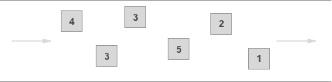
   2. FIFO

C:\Users\pxp167\Desktop\sqs-what-is-sqs-fifo-queue-diagram.png

1. Comparison:

|  |  |  |
| --- | --- | --- |
|  | Standard | FIFO |
| Default | Yes | No |
| Guarantee that Msg. will deliver | At least once | Only once |
| Duplicate | Yes | NO |
| Order | Try max to keep the same order that they sent | Strictly follow the order |
| Transactions |  | 300 /sec |

1. Msg. can kept in queue from 1 minute to 14 days. Default is 4 days.
2. Visibility time out: Amount of time that the message is invisible after read from queue.
   1. If job finishes before VTO expires, msg. will delete from the queue.
   2. Else, it will visible and chances are there to process the message by another job.
   3. Maximum VTO is 12 hours.
3. Polling types:
   1. Short poll:
      1. Default one.
      2. Will return response even queue is empty. That may increase the cost.
   2. Long poll:
      1. Return only the queue is not empty or time out happens.

## C:\Users\pxp167\Desktop\App_Services_copy_Amazon_SWF-512.pngSimple Workflow Service (SWF)

1. Used for coordinate work across distributed application components.
2. Comparison between SQS and SWF:

|  |  |  |
| --- | --- | --- |
|  | **SQS** | **SWF** |
| Retention Period | 14 Days | 1 Year |
| API | Message oriented | Task oriented |
| Message processed | Need to ensure that only once | Only Once |
| Duplication | Need to handle duplicate message | Never |
| Keep Tracks | Need to create application-level tracking | Yes |

1. SWF Actors:
   1. Workflow Starters: Application that start the workflow.
   2. Deciders: Control the flow of activity tasks.
   3. Activity workers: Do activity tasks.

## C:\Users\pxp167\Desktop\App_Services_copy_Amazon_SNS-512.png**Simple Notification Service**

1. Used for sending notifications
2. Push notification services:
   1. Amazon Device Messaging (ADM)
   2. Apple Push Notification Service (APNS) for both iOS and Mac OS X
   3. Baidu Cloud Push (Baidu)
   4. Google Cloud Messaging for Android (GCM)
   5. Microsoft Push Notification Service for Windows Phone (MPNS)
   6. Windows Push Notification Services (WNS)

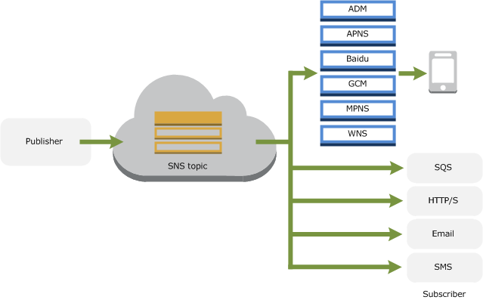

1. Also messages can be push to SQS, SMS, email, http/s and lambdafunctions**.**
2. AWS store messages inside **multiple AZ** to avoid data loss.
3. SNS is **PUSH** basted delivery.

## Elastic Transcoder

1. Used to convert from one media format to other.

## C:\Users\pxp167\Desktop\195-1955710_api-gateway-icon-assertible-logo-aws-api-gateway-logo.pngAPI Gateway

1. Create REST and WebSocket APIs that act as a “front door” for applications.

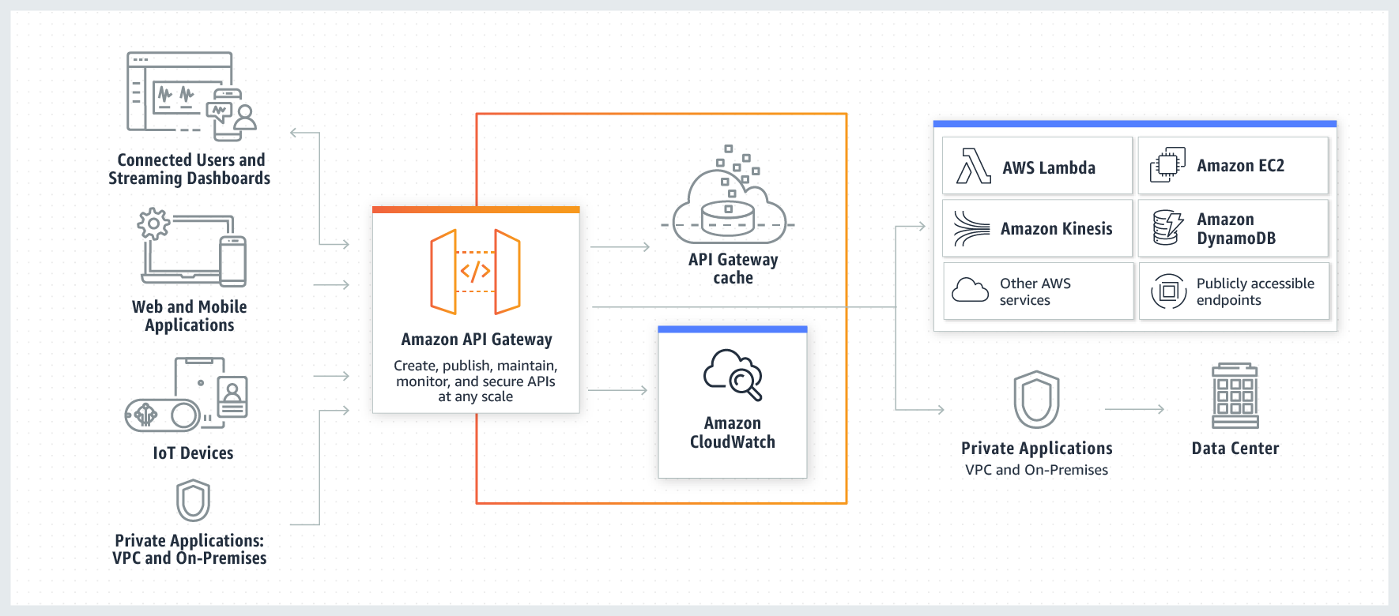

1. API caching: Once enabled, speed up the response by saving the response for specified time (TTL) and responds this response for subsequent requests.
2. Must enable the Cross origin resource sharing (CORS).

## C:\Users\pxp167\Desktop\20246904851536298169-512.pngKinesis

1. Used to load and analyses streaming data.
2. Services:
   1. Kinesis Streams
   2. Kinesis Firehose
   3. Kinesis Analytics
3. Kinesis Streams
   1. By default it will store data for 24 hours. Also can upgrade to 7days.
   2. Data stored in shards.
4. Kinesis Firehose
   1. No need to worry about shards and streams and fully automated.
   2. Data will send to S3 or redshift or elastic search cluster.
5. Kinesis Analytics
   1. Allow to run SQL queries and store the data into S3/Redshift/ElasticSearchCluster.